Name :Taimoor MANZOOR
ID:SP20-BSCS-0021

Task1
TASK2
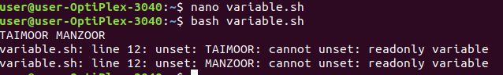
TASK 3
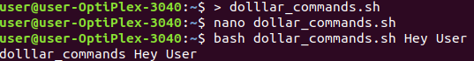

TASK4
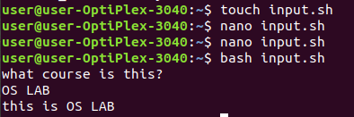

TASK 5
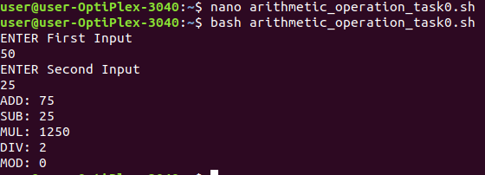
TASK6
